Abdurrahman Qureshi

210451

EXP16

-----------------------------------------------------------

1)**Code :**

#include<iostream.h>

#include<conio.h>

class sample

{

int x,y;

public:

void getdata();

void operator -();

void putdata();

};

void sample::getdata()

{

cout<<"\nEnter the value for x : ";

cin>>x;

cout<<"\nEnter the value for y : ";

cin>>y;

}

void sample::putdata()

{

cout<<"\nx:"<<x<<endl<<"y:"<<y;

}

void sample::operator -()

{

x=-x;

y=-y;

}

void main()

{

clrscr();

sample s1;

s1.getdata();

s1.putdata();

-s1;

cout<<"\n\nAfter using unary operator(-):

"<<endl;

s1.putdata();

getch();

}

**Output:**

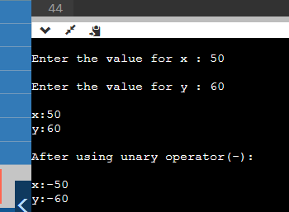

**2)CODE:**

#include<iostream.h>

#include<conio.h>

class sample

{

int x,y;

public:

void getdata();

void operator ++();

void putdata();

};

void sample::getdata()

{

cout<<"\nEnter the value for x : ";

cin>>x;

cout<<"\nEnter the value for y : ";

cin>>y;

}

void sample::putdata()

{

cout<<"x:"<<x<<endl<<"y:"<<y;

}

void sample::operator ++()

{

x=++x;

y=++y;

}

void main()

{

clrscr();

sample s1;

s1.getdata();

s1.putdata();

++s1;

cout<<"\n\nAfter using unary operator(++):\n";

s1.putdata();

getch();

}

**Output:**

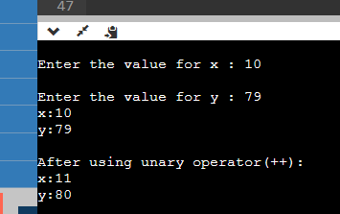

**3)CODE:**

#include<iostream.h>

#include<conio.h>

class sample

{

int x,y;

public:

void getdata();

void operator --();

void putdata();

};

void sample::getdata()

{

cout<<"\nEnter the value for x : ";

cin>>x;

cout<<"\nEnter the value for y : ";

cin>>y;

}

void sample::putdata()

{

cout<<"\nx:"<<x<<endl<<"y:"<<y;

}

void sample::operator --()

{

x=--x;

y=--y;

}

void main()

{

clrscr();

sample s1;

s1.getdata();

s1.putdata();

--s1;

cout<<"\n\nAfter using unary operator(--) :

"<<endl;

s1.putdata();

getch(); }

**Output:**

: 